CSCE 211: Digital Logic Design Spring 2022
Homework 4 03/21/22
This homework consists of 7 questions. Please find the corresponding questions from Section 5.10 in your textbook.

Follow this link to find Decoder and MUX instructions:
https://cse.sc.edu/~huangct/CSCE211S22/Function-MUX-Decoder.htm

Follow this link to find the circuit diagram and pin map of 3-to-8 Decoder, 74LS138 (answer question 4 using the pin map, figure (b) on the right side):
https://cse.sc.edu/~huangct/CSCE211S22/74x138.pdf

Follow this link to find the circuit diagram and pin map of 8-to-1 MUX, 74LS151 (answer question 3 using the pin map, figure (b) on the lower right side):
https://cse.sc.edu/~huangct/CSCE211S22/74x151.pdf
1. (0.2 points) Problem 1.a.i and 1.b from Section 5.10. Assume that there is a small delay ∆ at each gate (from the input to the output). Your answer should be how many ∆’s for each part of this question.
1.a.i: $6Δ$
1.b: $3Δ$
2. (0.3 points) Problem 7 from Section 5.10. You only need to write out functions X and Y from the diagram as sum of minterm numbers expression.

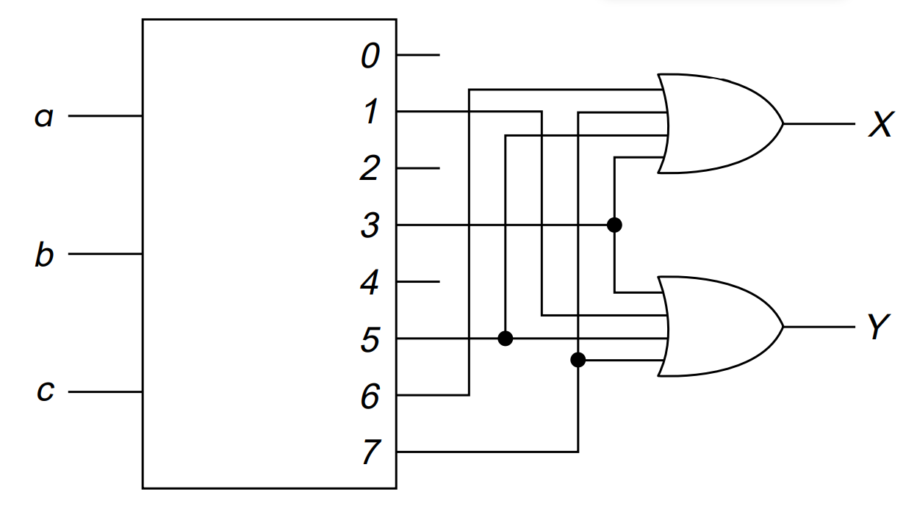
X(a,b,c)=$∑m(3,5,6,7)$
Y(a,b,c)=$∑m(1,3,5,7)$

3. (0.5 points) Use an 8-to-1 MUX (74LS151 below) to implement f(W, X, Y, Z) = ∑m(1, 2, 4, 5, 7, 12, 13). Pair rows (0-1, 2-3, ...) so that MUX inputs are 0, 1, Z, or Z'. First, develop the truth table and apply row-pairing method. Then, show the 74LS151 chip enabled, connect variables to address lines, and label function output.
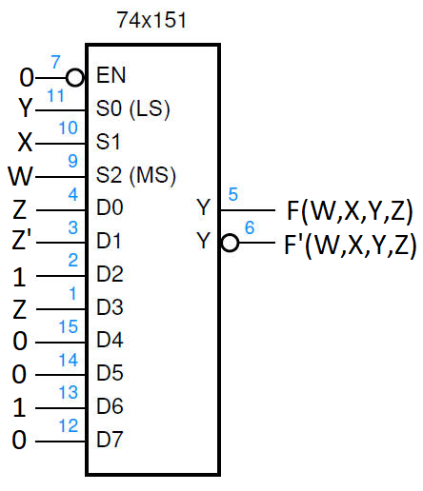
ROW | W | X | Y | Z | F(W,X,Y,Z) | Input
0 | 0 | 0 | 0 | 0 | 0 | D0=Z
1 | 0 | 0 | 0 | 1 | 1
2 | 0 | 0 | 1 | 0 | 1 | D1=Z'
3 | 0 | 0 | 1 | 1 | 0
4 | 0 | 1 | 0 | 0 | 1 | D2=1
5 | 0 | 1 | 0 | 1 | 1
6 | 0 | 1 | 1 | 0 | 0 | D3=Z
7 | 0 | 1 | 1 | 1 | 1
8 | 1 | 0 | 0 | 0 | 0 | D4=0
9 | 1 | 0 | 0 | 1 | 0
10 | 1 | 0 | 1 | 0 | 0 | D5=0
11 | 1 | 0 | 1 | 1 | 0
12 | 1 | 1 | 0 | 0 | 1 | D6=1
13 | 1 | 1 | 0 | 1 | 1
14 | 1 | 1 | 1 | 0 | 0 | D7=0
15 | 1 | 1 | 1 | 1 | 0

4. (0.5 points) Use a 3-to-8 DECODER (74LS138 below) and an external gate AND or NAND with the fewest inputs to implement f(x, y, z) = ∑m(0, 1, 4, 6, 7). (Hint: AND the Maxterms, NAND the minterms.) Show chip enabled, connect variables to address lines, and label the function output.
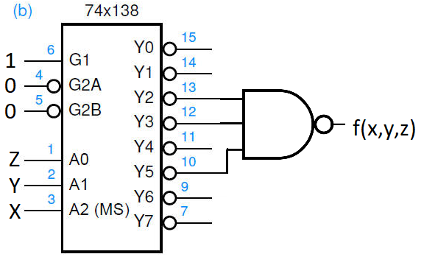
5. (0.5 points) Problem 9 from Section 5.10. Build a 3-to-8 decoder by "stacking" two 2-to-4 decoders, each of which has an active low enable input. See page 312. Use the most significant function variable "a" and an external inverter to enable the correct decoder. Variables "b" and "c" are connected to decoder lines "A (MS)" and "B". Label the decoder outputs m0 to m3 (top) and m4 to m7 (bottom).
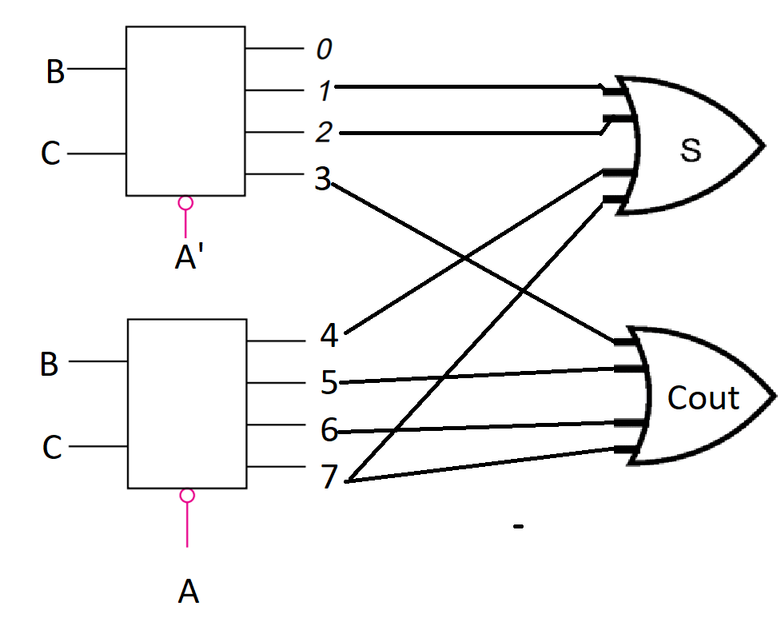

6. (0.5 points) Problem 12 from Section 5.10 but you have to use a 4-to-1 MUX (as provided below) and row pairing. Assume z' is available.
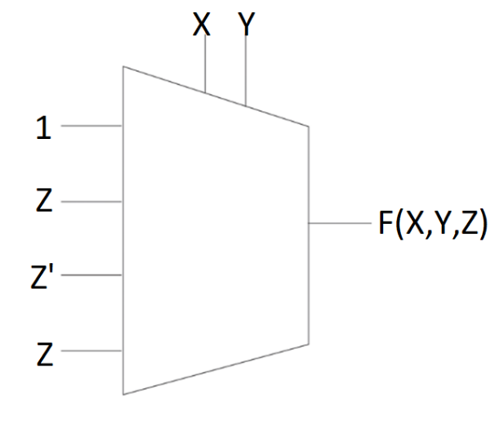
ROW | X | Y | Z | FX,Y,Z) | Input
0 | 0 | 0 | 0 | 1 | D0=1
1 | 0 | 0 | 1 | 1
2 | 0 | 1 | 0 | 0 | D1=Z
3 | 0 | 1 | 1 | 1
4 | 1 | 0 | 0 | 1 | D2=Z'
5 | 1 | 0 | 1 | 0
6 | 1 | 1 | 0 | 0 | D3=Z
7 | 1 | 1 | 1 | 1

7. (0.5 points) For the following set of functions, design a system (i) using a ROM; and (ii) using a PAL.
F(A, B, C, D) = AB'C + A'D'
G(A, B, C, D) = A'BD + AC'D' + B'CD'

(i) using a ROM:

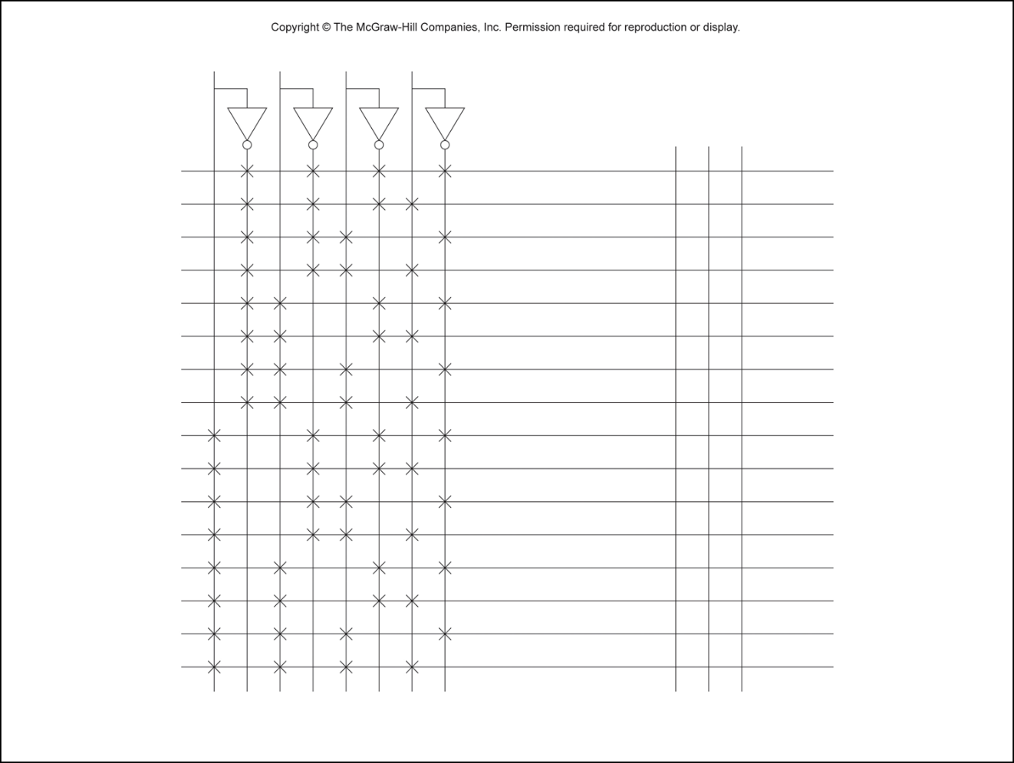

(ii) using a PAL:

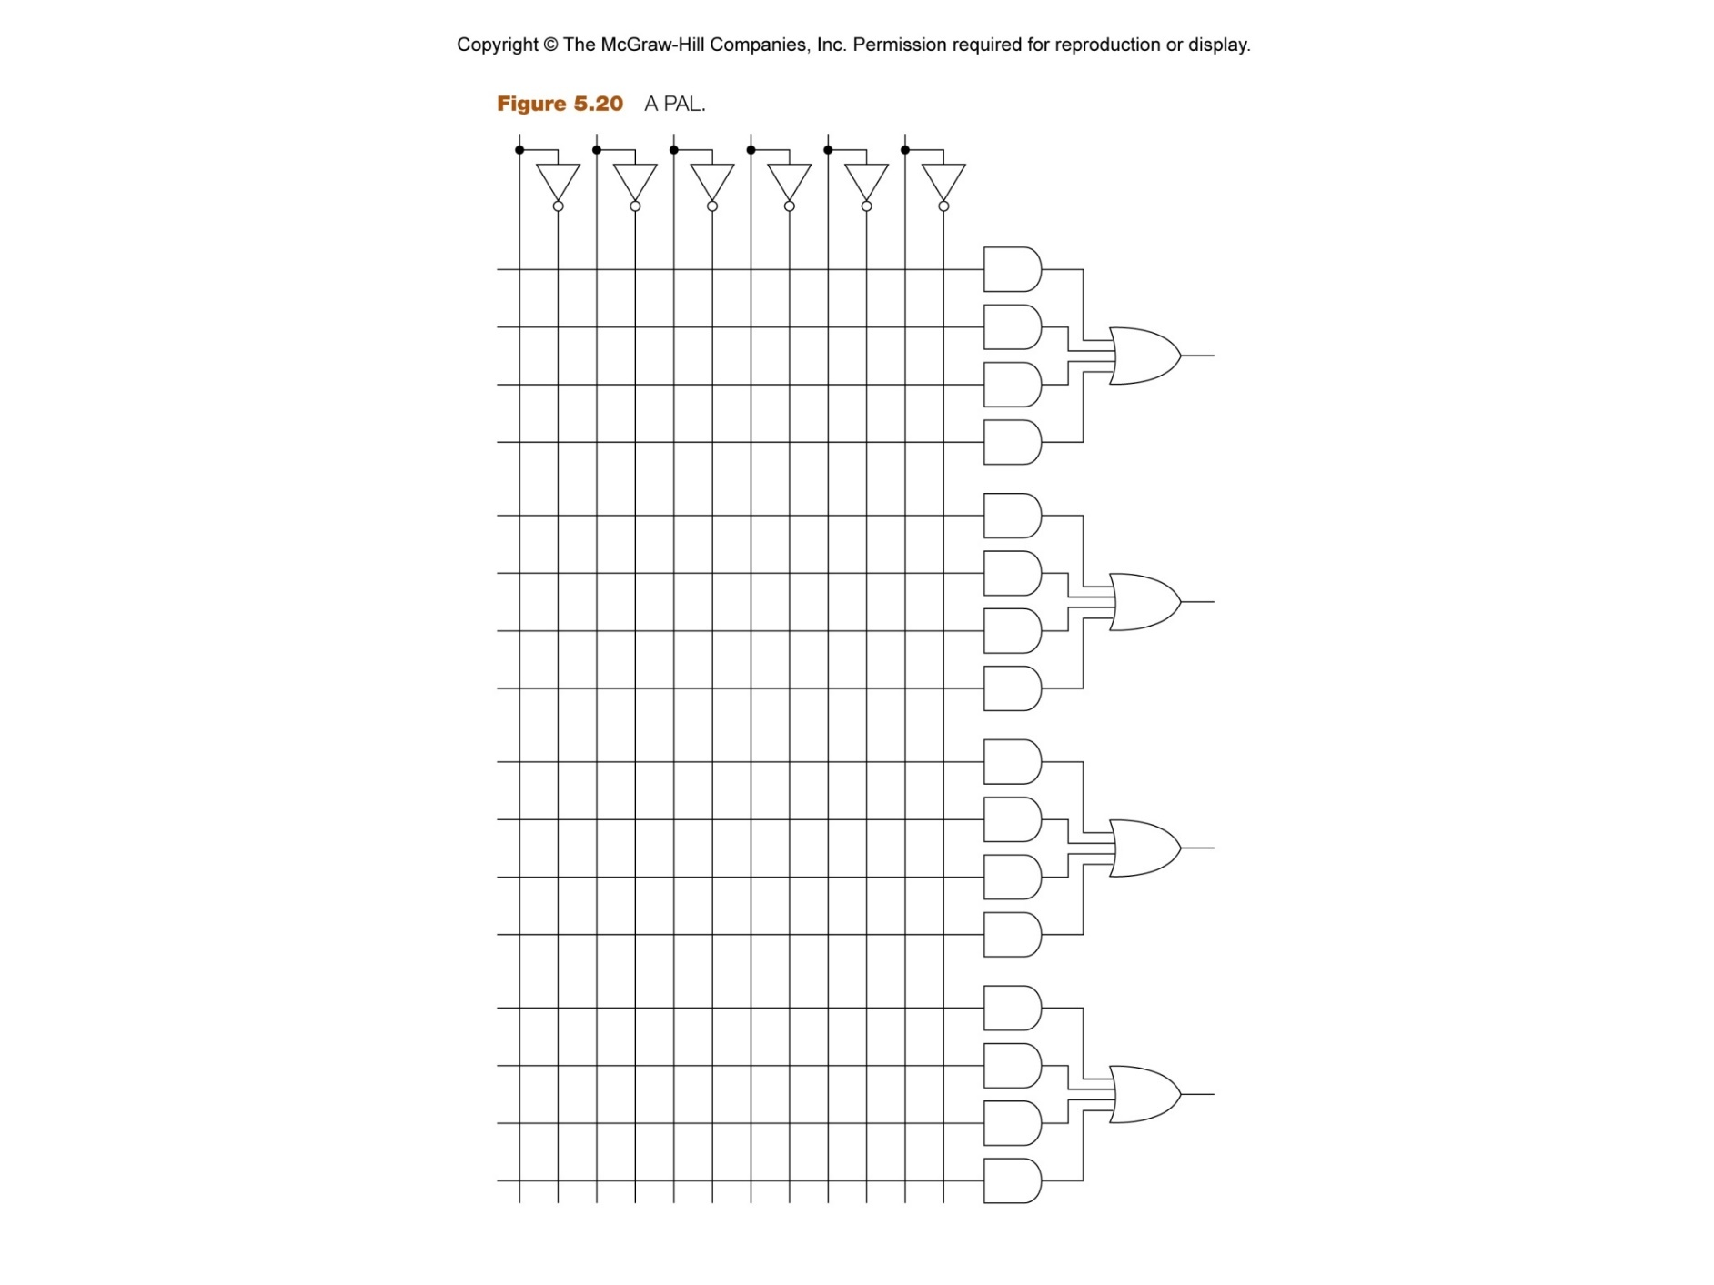

This homework accounts for 3 points toward your final grade. You need to submit by uploading the pictures of every page of your work or a scanned PDF file of all the pages. In order to get the points, you need to show the steps that lead to your answer. This homework is due on Mar. 28 on the Blackboard.

